1) Inverse Transform Method to Generate Random Variables

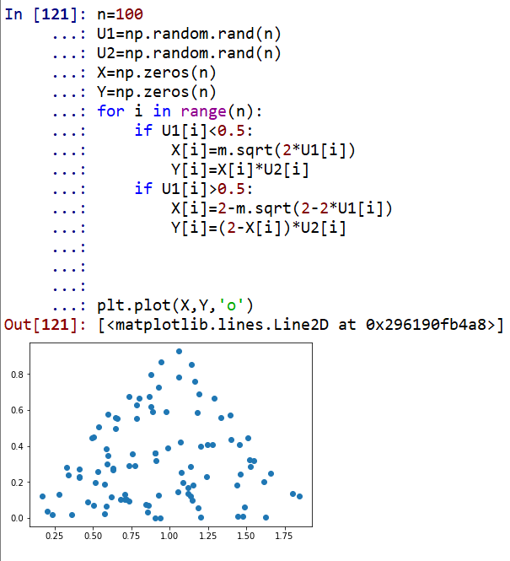

2）d-dimension unit random variables

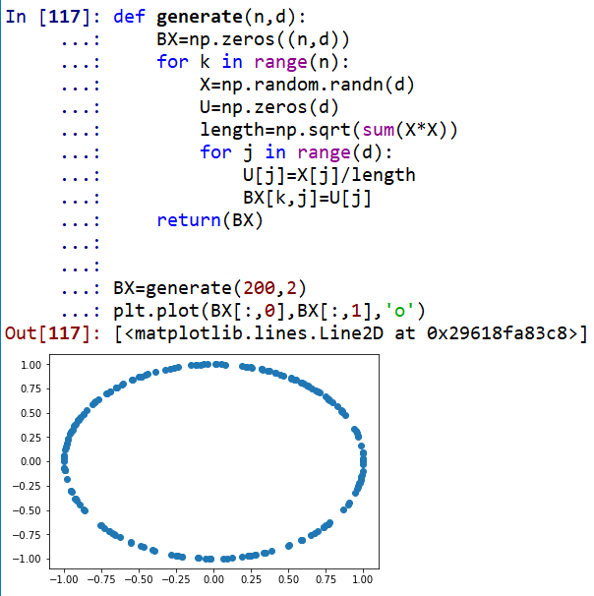

3) Remedian

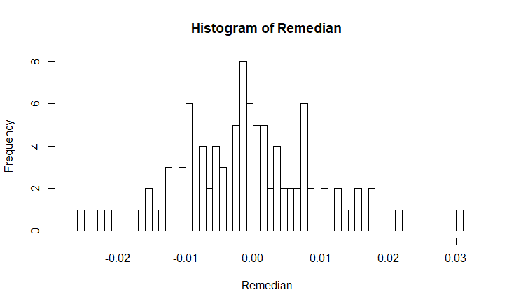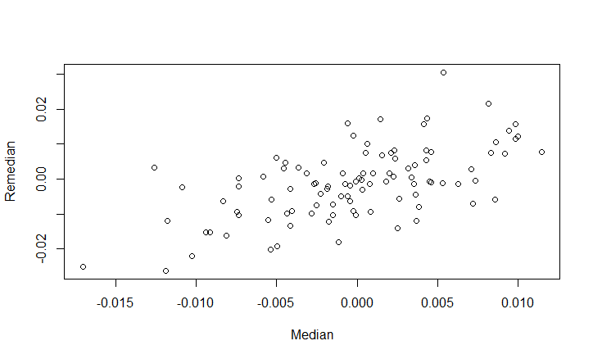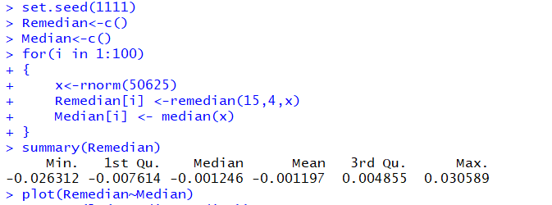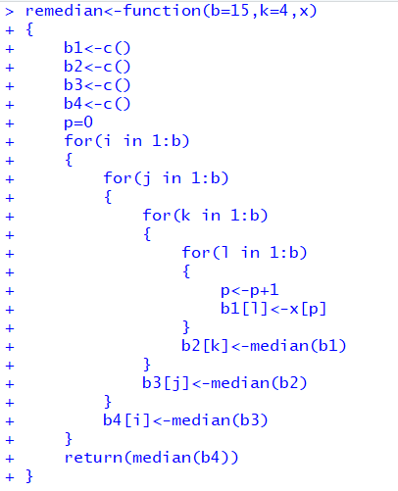

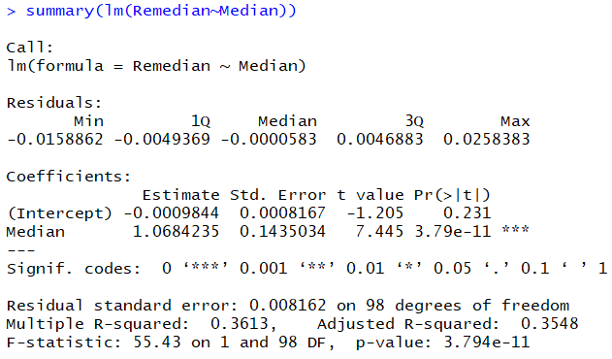

From the above linear regression model of Remedian and True Medain, we see the F-statistic is significant. The intercept is not significant, and the coefficient is significant and approximate to 1. So we can say Remedian is nearly equal to the True Median and we can use Remedian to estimate Median directly.

4) Random Walk

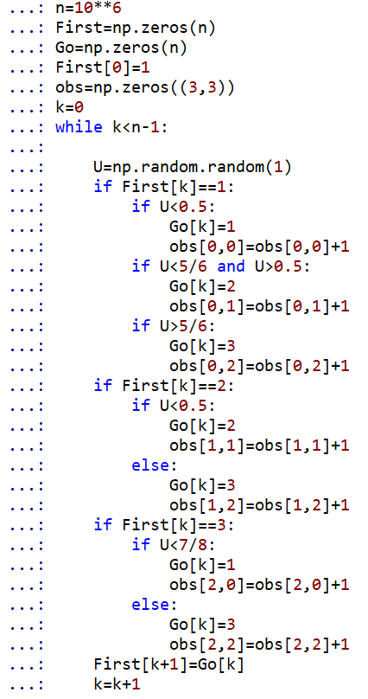

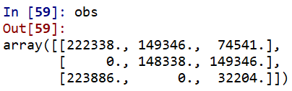



5）Newton-Raphson

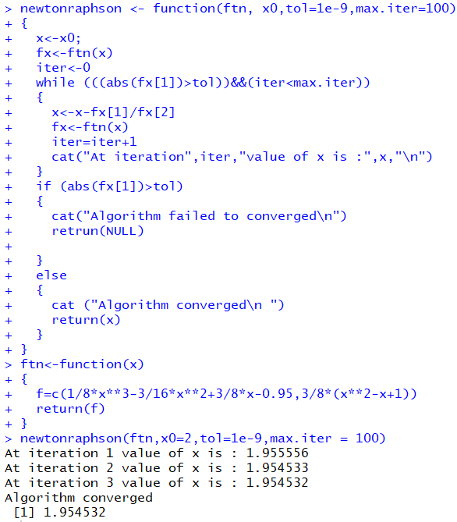

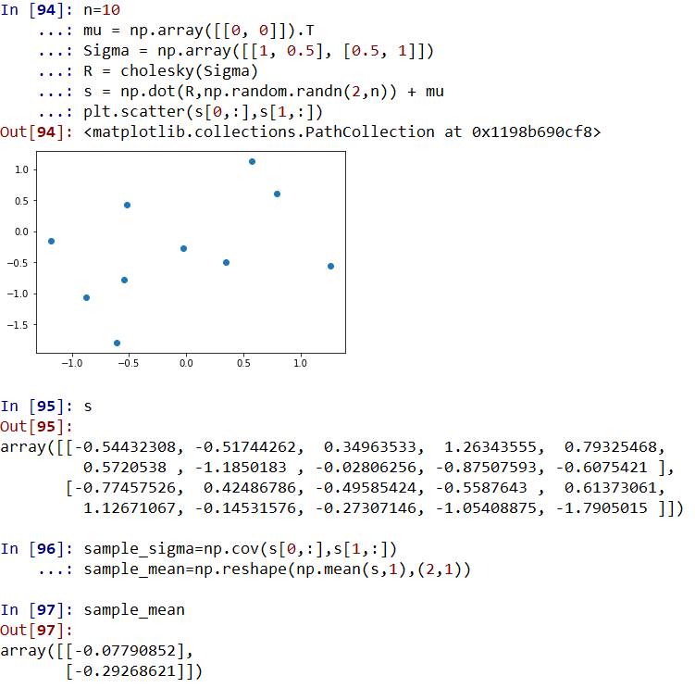6)

a)

**Observation**

**Mean**

**Covariance**

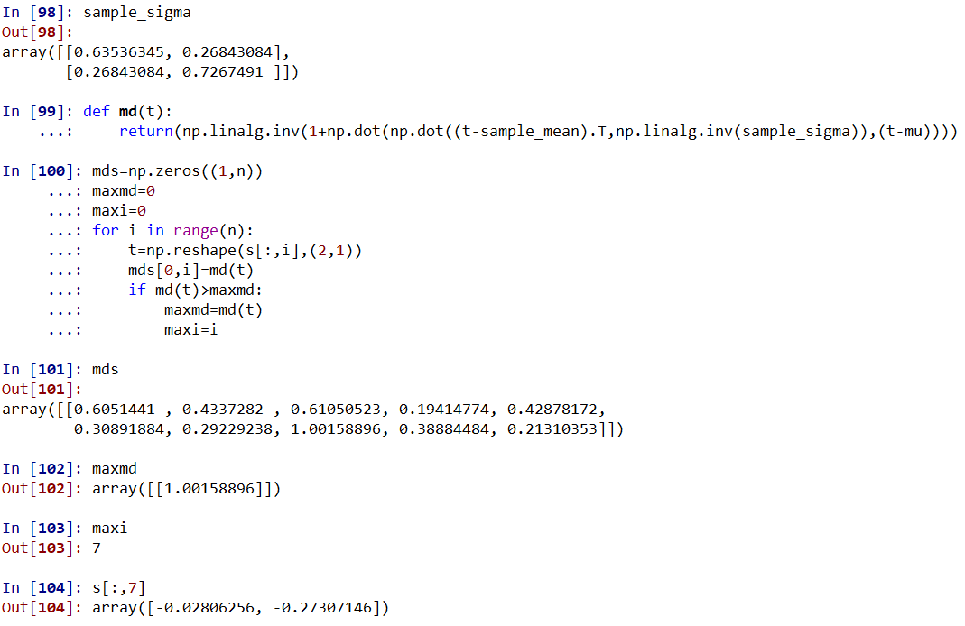

**Depth**

**The bivariate vector that maximizes the depth function**

b)

